Author: Victoria Scott

Okundaye, Nike

Chief (Mrs.) Oyenike Monica Okundaye, better known as Nike, is a painter and textile artist who has had a profound impact on the preservation and promotion of the indigo-dyeing and batik arts of Nigeria. She was initially recognized in the 1970s for her work in batik. In recent years, her interest has turned to painting. She formed a unique partnership with Nigerian artist, Tola Wewe in which they both work on the same canvas. The overall composition of the joint work tends to follow Wewe's style while the detail and layering of textile-inspired patterns is contributed by Nike drawing on her deep knowledge of the Yoruba adire textile tradition. Together they create a unique contemporary expression of a deep Nigerian aesthetic sensibility. Nike plays a prominent role in Nigeria's vital contemporary art scene as an artist, entrepreneur and educator. She is well known and respected at home and abroad. She serves as an adviser to national and state governments on cultural matters and she travels widely to lecture and represent Nigerian art on the international stage. As well as galleries in Oshogbo and Abuja, Nike owns and directs one of the largest galleries in West Africa, the Nike Gallery in Lagos where she shows works by fellow Nigerian artists. Nike herself designed the buildings that house her businesses.

Born in the remote village of Ogidi in Kogi State, Nigeria in 1954, Nike lost her beloved mother at the age of eight. She and her younger brother, Joseph Olabode, were raised by their father, a taciturn farmer who never remarried. Her childhood was harsh and uncharacteristically isolated for a Nigerian child. She learned to negotiate the African marketplace at an early age to support herself and her brother by petty trading and odd jobs.

Nike harbored greater ambitions as she was growing up. When her father arranged a marriage to an older man not of her choosing, she ran away and joined a theatre company. A brash young artist with the improbable name Twins Seven Seven who was also from Ogidi, enticed her to join him and his growing polygamous family in Oshogbo, a prosperous commercial center in what is now Osun State. Nike was soon pregnant with their first child, Olabayo, who was born in April, 1970.

Seven Seven was a rising star among the Oshogbo Group of artists. He taught Nike to draw, and she became a valuable studio assistant. Because there was no infrastructure in Nigeria to market the art they made, Seven Seven established his own gallery. Nike drew upon her experience as a trader and improved her language skills while entertaining visitors to their gallery.

Nike was not satisfied with her role in Seven Seven's studio, and she determined to establish her own career. She reasoned that abandoning pen and ink would help her to distinguish herself from Seven Seven and other Oshogbo artists. She turned to the starch resist method and indigo dye of the adire textile tradition she had learned from her great grandmother. Her first experiments were done on cotton broadcloth using a cassava starch resist and traditional Yoruba indigo dye.

Nike normally worked late when the compound was quiet. One night some melted wax from her candle dropped unnoticed onto the cloth. Later when the piece finished, she was struck by the brightness of the spot where the candle wax had resisted the dye. Thus she "discovered" the ancient art of wax batik.

The wax resist proved much more robust and versatile than the traditional starch. Initially Nike struggled to find an effective means to apply the wax. She found the Asian tjanting (which consists of a small metal cup with a handle and spout) was difficult to manipulate because the hot wax quickly congealed and clogged the spout. She devised a simple, effective method of applying the wax resist. She cut pillow foam into a cone shape and by applying a steady, gentle pressure on the liquid wax laden "foam brush", she could produce a long, fluid line.

Most of the original Oshogbo artists jealously guarded the secrets of their materials and methods, but Nike's generous spirit led her to teach others this versatile new medium. She began by instructing her co-wives in Seven Seven's compound, and soon they were producing marketable batiks. Their husband approved of their enterprise as he claimed a substantial share of their income.

Nike's simple materials and methods made the difficult technique of wax batik accessible to relatively unskilled people. Even children could know the satisfaction of creating wax resist designs. Her workshops became popular at home and abroad and she travelled widely to teach and exhibit her work.

While Nike's career flourished, she grew unhappy with the jealousy and abuse in Seven Seven's compound. She bought a plot of land nearby and quietly built her own house. When it was complete, she packed her possessions and moved out, much to Seven Seven's surprise. Several wives followed her.

Her success as a teacher inspired Nike to establish a school to train girls in the art of adire. Nike wanted to give young women a means of self-determination and promote the continuation of the adire tradition. In 1983, she established the Nike Centre for Art and Culture in Oshogbo. She soon expanded her vision for the school to include boys as well as girls and extended her curriculum to other traditional and modern art forms including beadwork, drumming, dance, printmaking, batik, painting, etc.

The administrative structure of the school draws on African and European models. Students who demonstrate mastery can choose to become teachers. The core curriculum is based on the tradition of adire design principles that Nike distilled into a series of lectures. The school is tuition free to all who qualify.

Nike also established a workshop in her hometown, Ogidi, to benefit the women of the village. They produce hand-woven cloth and adire. She built comfortable guesthouses at the Nike Centres in Oshogbo and Ogidi where visitors enjoy Nigerian hospitality, performance and traditional arts and crafts.

References and further reading:

Davies-Okundaye, N., Ritka Carr ed., (2008) Beyond Indigo: Adire Eleko Squares; Patterns and Meanings, Lagos: Nike Art Centre.

McKinley, C. E. (2011) Indigo: In Search of the Color That Seduced the World, , Bloomsbury Books.

Probst, P. (2011) Osogbo and the Art of Heritage: Monuments, Deities, and Money (African Expressive Cultures), Bloomington:
Indiana University Press.

Vaz, K. M. (1995) The Woman With the Artistic Brush: A Life History of Yoruba Batik Artist Nike Davies, M.E. Sharpe,

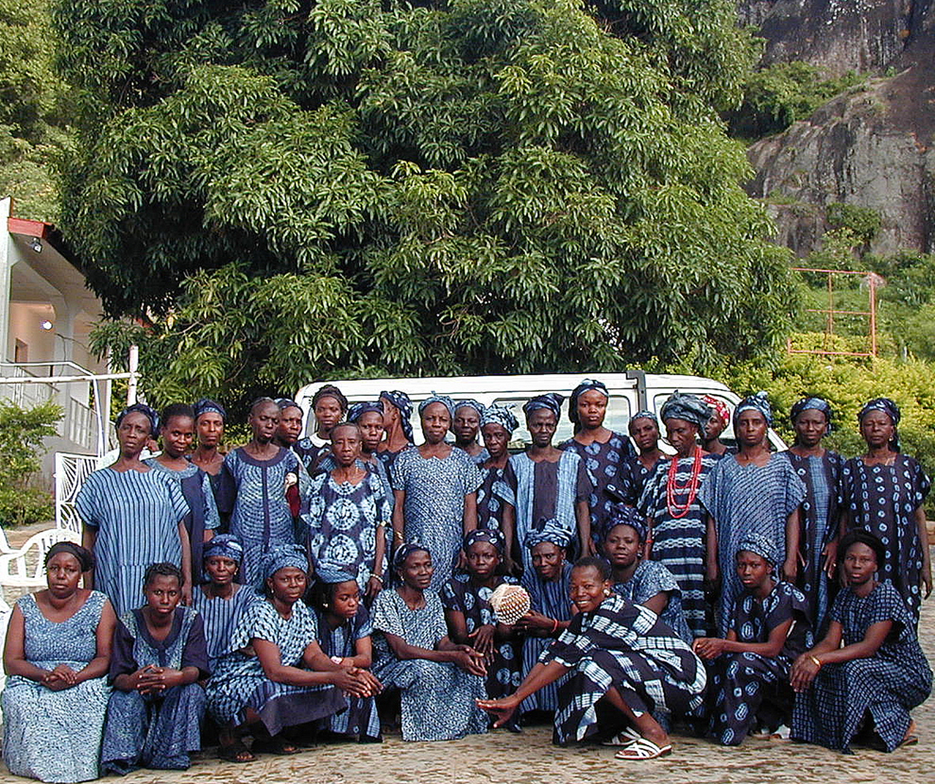
Nike “Davies” Okundaye (front) dressed in adire with the women of her workshop in Ogidi, Nigeria. Photo copyright Victoria Scott (author)

